Nosecone Geometry

Created by Andrew Smelser
Created on 12-04-2025

REVISION HISTORY
REVISION | DATE | DESCRIPTION OF CHANGES
F1 | 12-04-2025 | Original Release

EXECUTIVE SUMMARY

If you want to make sure it has a chance to be read, put it here.

Table of Contents
1.0 Introduction 1
2.0 NOSECONES 1
2.1 Tangent Ogive 2
2.2 Spherically Blunted Tangent Ogive 3
2.3 Conic 4
2.4 Spherically Blunted Conic 5
2.5 Bi-Conic 5
2.6 Haack Series 5
2.7 Parabolic 5
2.8 Power Series 5
2.9 Secant Ogive 5
3.0 Findings 6
4.0 Recommendations 6
5.0 Summary 6
6.0 References 7
Appendix A Here is an Example A-1
Appendix B Here is another Example B-1

List of Figures
Figure 1 The Various Styles of Nosecones 1
Figure 2 Tangent Ogive [1] 2
Figure 3 Model of Tangent Ogive Nosecone 2
Figure 4 Tangent Ogive Curve 3
Figure 5 Equation Driven Curve 3
Figure 6 Spherically Blunted Tangent Ogive Terms [2] 4
Figure 7 Spherically Blunted Tangent Ogive 4
Figure 8 Conic Nosecone Geometry [3] 5
Figure 9 Conic Nosecone 5

List of Tables
No table of figures entries found.

List of Attachments
- Example 1
- Example 2

List of Symbols and Acronyms
SYMBOL/ACRONYM | DEFINITION

Introduction
This document will provide an overview of the equations used to generate different nosecone shapes.

NOSECONES
There are a few different kinds of nosecone shapes, shown below in Figure 1.
- Tangent Ogive (see Section 2.1)
- Spherically Blunted Tangent Ogive (see Section 2.2)
- Conic (see Section 2.3)
- Spherically Blunted Conic (see Section 2.4)
- Bi-conic (see Section 2.5)
- Haack Series (see Section 2.6)
- Parabolic (see Section 2.7)
- Power Series (see Section 2.8)
- Secant Ogive (see Section 2.9)
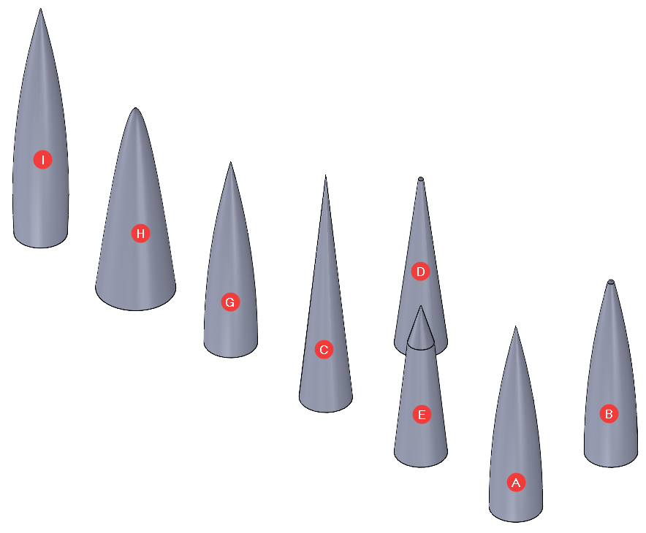
Figure 1 The Various Styles of Nosecones

Tangent Ogive
The tangent ogive uses a radius to form the outer shape of the nosecone. The shape is taken from a portion of a circle as shown in Figure 2. The modeled tangent ogive nosecone can be seen in Figure 3.
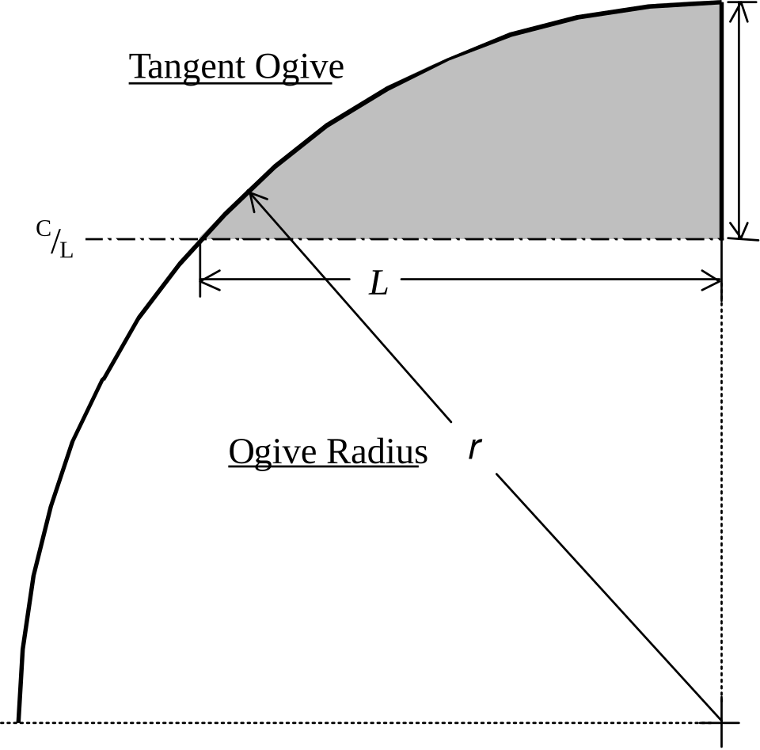  Figure 2 Tangent Ogive [1] | 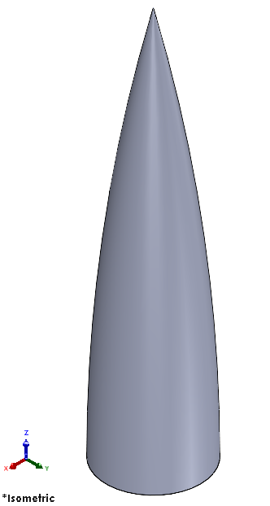  Figure 3 Model of Tangent Ogive Nosecone
The radius of the circle is called the ogive radius, ρ, and is given by Equation 2-1. The radius, y, at any point x along the parametric curve is given by Equation 2-2 as x varies from 0 to L. Design parameters used in the equations include: R the radius of the nosecone base; and L the overall length of the nose cone.
$$ρ = \frac{R^{2} + L^{2}}{2*R}$$ | 2-1
$$y = \sqrt{ρ^{2} - {\left(L - x\right)}^{2}} + R - ρ$$ | 2-2
The equations used to generate the parametric curve in SolidWorks is shown below:
$$y = \sqrt{ρ^{2} - {\left(\left(L - x_{t}\right) - x\right)}^{2}} + R – ρ$$ | 2-3
$$x_{1} = 0$$ | 2-4
$$x_{2} = L - x_{t}$$ | 2-5
This parametric curve can be used to generate the generic (pointed) tangent ogive shape. This is the right-most curve shown in Figure 4. This is accomplished using an Equation Driven Curve feature (Figure 5).
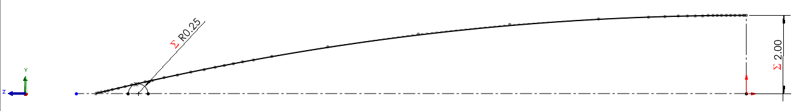  Figure 4 Tangent Ogive Curve | 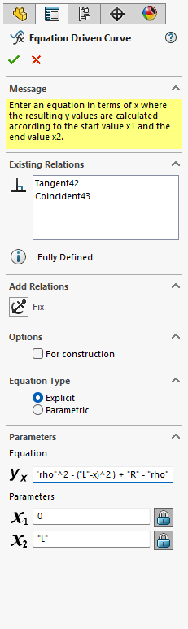  Figure 5 Equation Driven Curve

Spherically Blunted Tangent Ogive
The spherically blunted tangent ogive is a sub-type of the Tangent Ogive (Section 2.1). The tip of the nosecone is blunted by a sphere. An example of a spherically blunted tangent ogive nosecone is seen below in Figure 7.
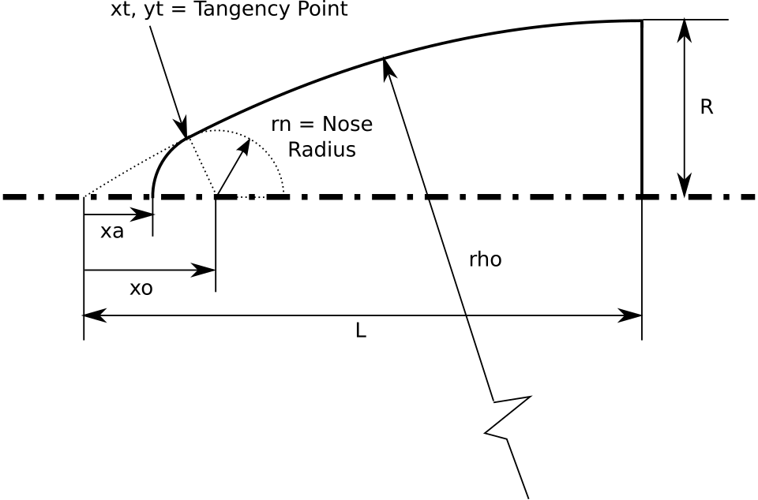  Figure 6 Spherically Blunted Tangent Ogive Terms [2] | 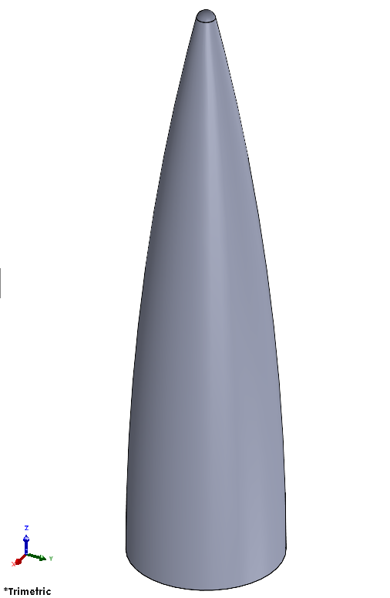  Figure 7 Spherically Blunted Tangent Ogive
The equations used to generate this shape rely on the following global variables:
$$ρ = \frac{R^{2}+L^{2}}{2*R}$$ | 2-6
$$x_{o} = L - \sqrt{{\left(ρ - r_{n}\right)}^{2} - {\left(ρ - R\right)}^{2}}$$ | 2-7
$$y_{t} = r_{n}\left(\frac{ρ - R}{ρ - r_{n}}\right)$$ | 2-8
$$x_{t} = x_{o} - \sqrt{{r_{n}}^{2} - {y_{t}}^{2}}$$ | 2-9
$$x_{a} = x_{o} - r_{n}$$ | 2-10

Where ρ is the radius of the ogive; x_{o} is the spherical cap center (relative to the origin); y_{t} is the tangency y-coordinate; x_{t} is the tangency x-coordinate; and x_{a} is the apex location (relative to the origin). These terms are shown below in Figure 6. Starting data is the same as that for the standard tangent ogive (see Section 2.1).

Conic
The conic nosecone is a simple triangular cross section axially rotated; see Figure 8 and Figure 9.
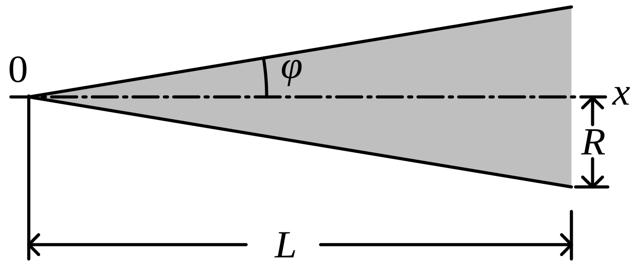  Figure 8 Conic Nosecone Geometry [3] | 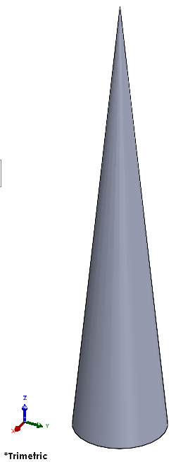  Figure 9 Conic Nosecone

Spherically Blunted Conic

Bi-Conic

Haack Series

Parabolic

Power Series

Secant Ogive

Findings

Recommendations

Summary

References

[1] | G. A. C. Sr., "File:Nose cone tangent ogive.svg," 1996. [Online]. Available: https://commons.wikimedia.org/wiki/File:Nose_cone_tangent_ogive.svg. [Accessed 04 12 2025].
[2] | JHuwaldt, "File:Spherically blunted tangent ogive geometry.svg," 21 01 2009. [Online]. Available: https://en.wikipedia.org/wiki/File:Spherically_blunted_tangent_ogive_geometry.svg. [Accessed 04 12 2025].
[3] | F. l. a. n. k. e. r. "File:Nose cone conical.svg," 06 05 2009. [Online]. Available: https://commons.wikimedia.org/wiki/File:Nose_cone_conical.svg. [Accessed 04 12 2025].

Here is an Example

Put your data here.

Here is another Example

Put your data here.

The Haack series is not shown in the figure.
Shown in Figure 1 as r

